SERVICE CENTRE MANAGEMENT
- Project Overview & Objectives:

Introduction: Reduce downtime of ACs without visiting the service centre by customers, they just do a call our mechanic and engineers repair and resolve the problems as soon as possible through smooth workflow.

Objectives: The main purpose of this project is bond with customers we check how frequently the services are required, customers are happy with the products or not so that organization improves their sales and goodwill.

2.Design Approach: It has nine tables.
a. Service Centre:
Fields | Data Type
ID | Int
Name | Varchar(50)
Address | Varchar(50)
Email | Varchar(50)
RegNumber | Int

b. Product Category:

Variable | Data Type
CategoryID | Int
CategoryName | Varchar(50)
Description | Varchar(50)

C. Products:
Variable | Data Type
ProductID | Int
Phone | Varchar(50)
CategoryID | Int
WarrantyInDays | Int
Price | Int

D. Service Types:

Variable | Data Type
ServiceID | Int
ServiceName | Varchar(50)
CategoryID | Int
ProductID | Int
Charges | Int
DaysToResolve | Int

E. Customers:

Variable | Data Type
CustomerID | Int
CustomerName | Varchar(50)
Email | Varchar(50)
Address | Varchar(50)
Phone | Varchar(50)

F. Engineers:

Variable | Data Type
EngineerID | Int
EngineerName | Varchar(50)
EngineerMail | Varchar(50)
CategoryID | Int
DateOfJoining | Varchar(50)

G. CallData:

Variable | Data Type
CallRefNumber | Int
CustomerID | Int
ProductID | Int
DateOfCall | Varchar(50)
DateOfResolve | Varchar(50)
AssignToEngineerID | Int

H. CallCloseData:

Variable | Data Type
CallRefNumber | Int
CustomerID | Int
EngineerID | Int
DateOfCall | Varchar(50)
DateOfClose | Varchar(50)
BillAmount | Int

- CallFeedback:

Variable | Data Type
CallRefNumber | Int
CustomerID | Int
EngineerID | Int
Feedback | Int
Remark | Varchar(50)

3.Implementation:

Concepts and Techniques:

Create Database SCM;
Use Database SCM;
Create table servicecentre(id int primary key, name varchar(50), address varchar(50), email varchar(50), regno int);
Create table productcategory(categoryid int primary key, categoryname varchar(50), description varchar(50));
Create table products(productid int primary key, phone varchar(50), categoryid int, warrantyindays int, price int);
Create table servicetypes(serviceid int primary key, servicename (50), categoryid int, productid int, charges int, daystoresolve varchar(50));
Create table customers(customerid int primary key, customername varchar(50), email varchar(50), address varchar(50), phone varchar(50));
Create table engineers(engineerid int primary key, ename varchar(50), email varchar(50), categoryid int, dateofjoining varchar(50));
Create table calldata(callrefno int primary key, customerid int, productid int, dateofcall varchar(50), dateofresolve(50), engineered int);
Create table callclosedata(callrefno int primary key, customerid int, engineerid int, dateofcall varchar(50), dateofclose varchar(50), billamount int);
Create table callfeedback(callrefno int primary key, customerid int, engineerid int, feedback int, remark varchar(50));

Codes:
#For servicecentre:
import tkinter
from tkinter import*
from tkinter import messagebox
from tkinter import ttk
import pymysql
t=tkinter.Tk()
t.geometry('800x800')
def savedata():
db=pymysql.connect(host="localhost",user="root",password="root",database="scm")
cur=db.cursor()
xa=int(ea.get())
xb=eb.get()
xc=ec.get()
xd=ed.get()
xe=int(ee.get())
sql="insert into servicecentre values (%s,%s,%s,%s,%s)"
cur.execute(sql,(xa,xb,xc,xd,xe))
db.commit()
messagebox.showinfo('data inserted')
db.close()

def finddata():
db=pymysql.connect(host='localhost',user='root',password='root',database='scm')
cur=db.cursor()
xa=int(ea.get())
sql="select name,address,email,regno from servicecentre where id=%s"
cur.execute(sql,(xa))
data=cur.fetchone()
eb.insert(0,data[0])
ec.insert(0,data[1])
ed.insert(0,data[2])
ee.insert(0,data[3])
db.close()

def updatedata():
db=pymysql.connect(host="localhost",user="root",password="root",database="scm")
cur=db.cursor()
xa=int(ea.get())
xb=eb.get()
xc=ec.get()
xd=ed.get()
xe=int(ee.get())
sql="update servicecentre set name=%s,address=%s,email=%s, regno=%s where id=%s"
cur.execute(sql,(xb,xc,xd,xe,xa))
db.commit()
messagebox.showinfo('hi','data updated')
db.close()

def deletedata():
db=pymysql.connect(host='localhost',user='root',password='root',database='scm')
cur=db.cursor()
xa=int(ea.get())
sql="delete from servicecentre where id=%s"
cur.execute(sql,(xa))
db.commit()
messagebox.showinfo('Hi','Data Deleted')
ea.delete(0,END)
db.close()

def showdata():
db=pymysql.connect(host='localhost',user='root',password='root',database='scm')
cur=db.cursor()
sql='select*from servicecentre'
records=''
cur.execute(sql)
data=cur.fetchall()
for m in data:
records=str(records)+str(m)+'\n'
db.close()
ta.insert("1.0",records)
ta=Text(t,width=100,height=20)
ta.place(x=50,y=50)
t.title('Servicecentre')
a=Label(t,text='id')
a.place(x=50,y=100)
ea=Entry(t,width=20)
ea.place(x=400,y=100)
b=Label(t,text='name')
b.place(x=50,y=160)
eb=Entry(t,width=40)
eb.place(x=400,y=160)
c=Label(t,text='address')
c.place(x=50,y=220)
ec=Entry(t,width=40)
ec.place(x=400,y=220)
d=Label(t,text='email')
d.place(x=50,y=280)
ed=Entry(t,width=40)
ed.place(x=400,y=280)
e=Label(t,text='regno')
e.place(x=50,y=340)
ee=Entry(t,width=40)
ee.place(x=400,y=340)

btn=Button(t,text='Save',command=savedata)
btn.place(x=200,y=400)
btn1=Button(t,text='Update',command=updatedata)
btn1.place(x=350,y=400)
btn2=Button(t,text='Find',command=finddata)
btn2.place(x=500,y=400)
btn3=Button(t,text='Delete',command=deletedata)
btn3.place(x=650,y=400)
btn=Button(t,text='Show',command=showdata)
btn.place(x=200,y=400)
t.mainloop()

# Display of the table attached below:

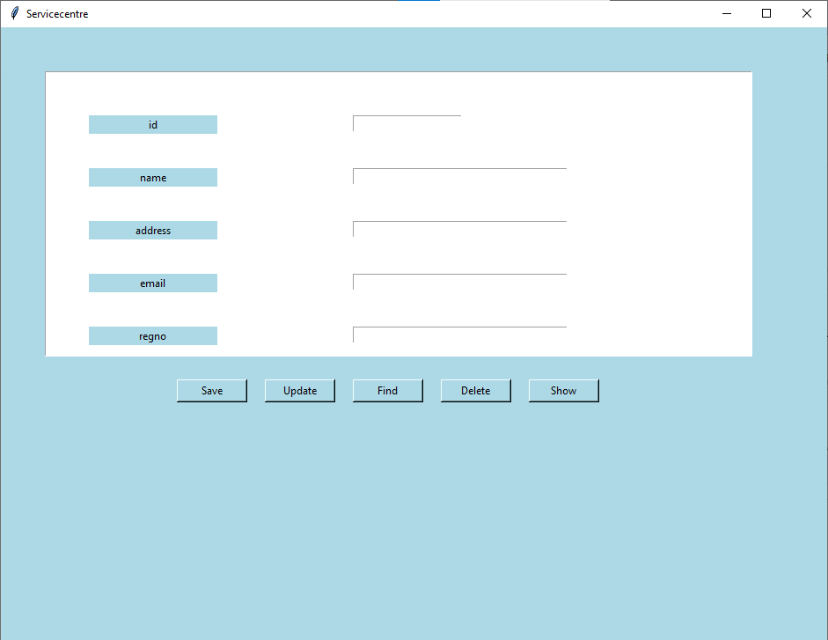

- Same for the other tables only variables and datatypes will change according to requirement.

4. Conclusion:
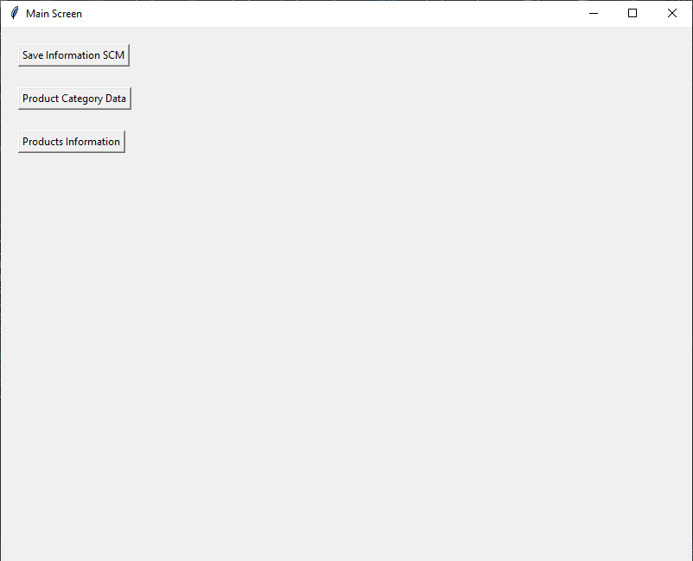

More features also we can add and update in the above dashboard.
The above Image shows final screen(Dashboard) on that we have buttons to click and access the data, also analyse the service centre growth and customers faith on the products.

Thank You, Have a Great Day!

